**Agile for world project**

**The agile model**

The agile model would be used throughout the whole process of creating our final design of our website. The agile model would consist of a cycle going back to the stage one of thinking of ideas and requirements we need to make our perfect website. Feedback would be the step which would determine if the website is able to be release to market or not. We would get feedback from the stakeholders where they would check the final prototype of the website to see if it has the requirements they wanted. If the stakeholders are not pleased with the prototype, we would have to start from scratch and see where we have gone wrong.

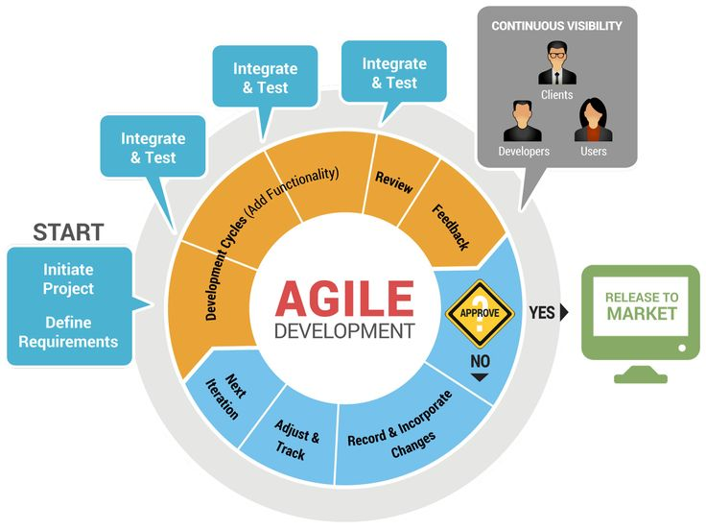

source: http://www.techtipsnapps.com/2015/04/most-successful-software-development.html

**Requirement**

The Requirement would be the first thing in the agile model, where Requirements would be sets of functions and limitation the users would expect from the system. The stakeholders would give their require requirements they want on the website. The requirements specification document would be created which would help serve a purpose of guiding for the next stage of the model. This stage my group would get requirements that are possible to create our website. We would get feedback on function and limitation the users would expect from the system. So the requirements would be defined after initiating project and after we would have high level requirements that would be the most important requirements throughout the project.

**Integration & test**

We would start integrating our system design and begin coding once storyboard design has been finalised. For each function code, they would be tested to make sure that the code is working and doing what we need it to do, if code isn’t up to standard, we go back and resolve the problem. Testing at this stage would to check out the whole design and the built of it to check the functionality. If there is any error in the design they will have to start the design again at this point of process to make sure everything is clear from any error.

**Review & feedback**

Once the prototype of the website has been finished, it would be release to stakeholders, developers and users to be able to test it for a short period of time. This would allow us to see if the website is good enough to be release to the market or not. This would be where feedback would come after, where they would inform us what needs to be changed, fix, any issues occurred when navigating through the website. If they aren’t pleased with then website then we would have to make sure to record the feedback and adjust them then begin a next iteration till we have resolved the issues from the last prototype.